**Hot and Cold Application**

**Learning outcomes**

1. 0 Knowing about heat and cold applications that serve as therapeutic measures and provides comfort

1.1 Heat & cold applications

1.2 Discuss the therapeutic uses of heat and cold therapy and their methods of application

1.3 Understand physiological reactions and untoward reactions resulting from these measures

* Application of heat and cold are commonly used in the hospital, and at home as therapeutic measures
* In the hospital, these measures are carried out at the direction of the physician
* Heat and cold applications serve as comfort measures
* The caregiver, therefore must have knowledge of the physiological reactions resulting from these measures
* And, also about any untoward reaction, which may occur due to improper application or even otherwise

**Principles of Heat & Cold Therapy**

**The Fundamental Laws of Physics**

1. Heat is always passed from a hotter body to a cooler one
2. Heat causes expansion and change of state
3. Heat is distributed throughout the body by the circulating blood and by direct conduction through the tissue
4. Heat is lost from the body chiefly through conduction, convection, radiation and evaporation
5. The amount of blood that circulates close to the surface of the skin is influenced by the dilatation, and constriction of the peripheral arterioles

**The Principles Apply to the Human Body**

Application of heat & cold influences;

* 1. Dilatation of and constriction of peripheral blood vessels
  2. Moisture conducts heat better than air

Ability to tolerate heat and cold varies from person to person;

* 1. Very old and very young people are very sensitive to heat & cold
  2. People become less sensitive to repeated action of heat & cold

**Application of Heat**

**Definition:** Application of heat means the use of an agent warmer than the skin, which may be applied in either a moist or a dry form - to produce a local or systemic effect or both

**Purpose:**

To promote circulation

To relieve congestion and reduce oedema or inflammation

To increase suppuration

To promote tissue relaxation

To relieve pain

To soften the exudates

To provide warmth & comfort

To stimulate peristalsis

To dry casts, moist wounds & burns

**CLASSIFICATION OF HEAT THERAPY**

|  |  |
| --- | --- |
| **DRY HEAT**   1. Hot water bottle 2. Heating lamp 3. Heating cradle 4. Electric pad 5. Infra-red lamp 6. Diathermy | **MOIST HEAT**   1. Fomentations 2. Stupes 3. Soaks/baths 4. Wax bath 5. Sitz bath 6. Aquathermia pads |

**Application of Cold**

**Definition:** Application of cold means using an agent on the skin - either moist or dry, and can be applied to produce a local or systemic effect or both

**Purpose:**

To reduce inflammation

To relieve pain

To prevent oedema and reduce inflammation

To control haemorrhage

To decrease metabolism and thus prevent gangrene

To reduce body temperature

To anaesthetise an area for a short period

To inhibit bacterial growth and prevent suppuration

**CLASIFICATION OF COLD THERAPY**

|  |  |
| --- | --- |
| **DRY**  Hypothermia warming blanket | **MOIST**   1. Cold sponge 2. Cold pack 3. Cold bath |

**Effect of Heat & Cold Therapy**

**Factors to be considered**

**Application depends on number of factors and, some of these are:**

1. The purpose of the application
2. The age of the patient, & the condition of the skin
3. The general physical health of the patient
4. The area of the body that is affected
5. The duration of the treatment
6. Intensity of the temperature of its application.

**Effect – Physiological Change of Heat Therapy**

Vasodilatation: increased capillary permeability, increased local metabolism, increased oxygen requirement

Decreased blood viscosity: increased blood flow, increased lymph flow, increased motility of leukocytes, reduced muscle tension

**Effect – Physiological Change of Cold Therapy**

Vasoconstriction: decreased capillary permeability, decreased local metabolism, decreased oxygen requirement

Increased blood viscosity: decrease blood flow, decreased lymph flow, decreased mobility of leucocytes, decrease muscle tension

**Secondary Effect of Heat Therapy**

* If the heat is applied for one hour or more vasodilatation will be always followed by vasoconstriction due to the reflex action as the body attempts to control excessive heat from the area
* Continuous exposure to heat also damages the epithelial cells, causing red ness, localised tenderness and even blistering

**Secondary Effect of Cold Therapy**

* If the cold application is prolonged, it results in reflex vasodilatation to prevent tissue ischaemia. which occurs due to inability to receive an adequate flow of blood & nutrition in the cells. Initially, the skin appears reddened , followed by bluish purple with numbness & burning type of pain.

**Secondary Effect of Heat Therapy**

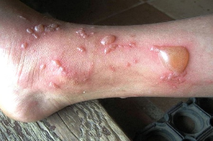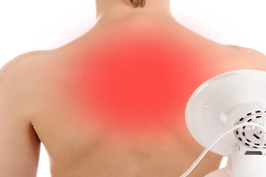

**Secondary Effect of Cold Therapy**

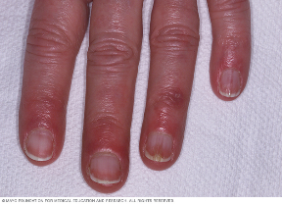 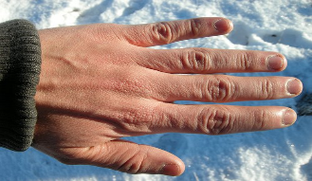

**DO NOT APPLY COLD/HEAT THERAPY:**

* In malignancy
* Oedema associated with venous & lymphatic disease e.g: arteriosclerosis, atherosclerosis which is common in Diabetes Mellitus (DM) patients, inhibits peripheral flow of blood
* Cutaneous injuries e.g: stoma or scar tissues
* Patients with paralysis
* In abscessed tooth or in an inflamed appendix as heat might cause these areas to rupture, spreading infection in the blood stream
* It should not be applied on very young or old patients or debilitated patients
* Disorders resulted in impaired circulation e.g: Diabetes
* Cold may be applied initially to a burnt area to reduce pain and to decrease the effect of hypoxia but after 24 hrs it may be contra indicated as it may retard the healing process
* Infected wounds
* Patients with decrease sensation in the affected area e.g: paralysed patient

**General Instructions for Therapy**

***Application of Hot & Cols Therapy must be done carefully***

1. Assess the condition of the patient prior to, during and after the application of the heat & cold therapy
2. Maintain the correct temperature for the entire duration of the application
3. Never use any equipment unless you know its operation completely
4. There must be a recovery period between the application of heat & cold because continuous applications are detrimental to the health of the tissues
5. Expose the patient only to a safe temperature, and double check
6. Do not allow the patient to adjust the control of temperature of appliances such as short – wave diathermy electric heating pads, etc.
7. Never ignore the complaints of a patient, however small they may appear to be
8. The patient must have calling signal within his reach
9. Do not use electrical appliances close to open oxygen, or near water, or other fluid, or handle them with wet hands
10. After the procedure, dry the part gently by patting and not by rubbing to remove the moisture, thereby preventing maceration of the skin, and further cooling by evaporation
11. During hot & cold applications, protect the patient from getting chills - shivering can raise the temperature and allows the patient to catch a cold
12. In hyperpyrexia, the temperature of the body should be brought down gradually and steadily - sudden cooling is dangerous to the patient